ED RAYYIS
MARKETING AUTOMATION & AI SOLUTIONS ARCHITECT & AUTHOR

(646) 745-6405 EDRAYYIS@GMAIL.COM LINKEDIN.COM/IN/RAYYIS SAN DIEGO CALIFORNIA WWW.RAYYIS.COM
I am an Adobe Marketo Engage architect with more than twenty years of experience in marketing operations, much of it serving Fortune 500 organizations in financial services, life sciences and technology.
My work centers on enterprise marketing automation: instance architecture, integration with Salesforce and Microsoft Dynamics 365, lead scoring and lifecycle design, platform migrations, and the governance and Centers of Excellence that keep the platform reliable long after implementation. I am a Certified Marketo Expert, and my campaign work has earned gold at Cannes Lions.
Agentic automation is now central to my work. I design and orchestrate AI agents that connect to live marketing systems through the Model Context Protocol and browser automation, so instance health audits and troubleshooting run as automated workflows. I am the author of Mastering Adobe Marketo Engage, a practitioner's reference for teams building on the platform.

EDUCATION | CERTIFICATION
European University Cyprus  1999 – BA Marketing | Certified Marketo Expert – Adobe  AWARDS
Cannes Lions - GOLD - Direct Marketing – Microsoft
Campaign Magazine - GOLD - Best Digital Campaign – Adidas
AUTHOR
Mastering Adobe Marketo Engage on Amazon

SKILLS
STRATEGY | PLATFORMS | AUTOMATION | TECHNICAL
MarTech Architecture  Solution Design  Roadmaps  Governance  Requirements Gathering  Stakeholder Alignment  Vendor Management  Training  Compliance | Marketo  AEM  AEP  AJO  Salesforce  Microsoft Dynamics  CDP  Eloqua  HubSpot | Campaign Build  Segmentation  Lead Scoring  Lead Routing  Personalization  A/B Testing  QA  Nurture Campaigns  Modular Templates | AI-Augmented Workflows  Agentic Automation  AI Agent Orchestration  Model Context Protocol (MCP)  Playwright Automation  LLM-Assisted Auditing  API Integrations  Webhooks  SQL/JSON/Jscript/HTML/CSS

INDEPENDENT CONTRACTOR
MARKETING AUTOMATION & AI SOLUTIONS ARCHITECT REMOTE / CONTRACT FEB 2021 – PRESENT
CLIENTS
 | Adobe |  | SAP |  | Dropbox
 | Henry Schein |  | Meta |  | Solidigm
 | AbbVie |  | Macy’s | 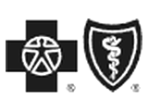 | Wellmark
 | Wolters Kluwer |  | Prudential |  | JP Morgan Chase
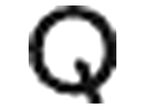 | Qualcomm |  | Cetera |  | Moderna
 | Frontier Telecom |  | Intuitive Surgical |  | Pfizer
 | MetLife |  | Cisco |  | Microsoft
- Platform Architecture & Integration: Designing and connecting marketing automation platforms across enterprise tech stacks, including instance setup, CRM sync (Salesforce, Dynamics 365), API development, webhook integration, and third-party platform connections, using AI-assisted architecture design to accelerate discovery, solution modeling, and documentation.
- Lead Scoring, Lifecycle & ABM Strategy: Designing AI-enhanced lead scoring models and lifecycle stage mapping from MQL to SQL, leveraging behavioral signals and predictive logic. Architecting tiered ABM programs with intent-driven audience builds, and sales-aligned workflows coordinated across CRM, CDP, and paid media.
- Data Modeling, Governance & Compliance: Defining field mappings and data relationships between systems, managing database hygiene, deduplication, and migration. Establishing data governance policies and managing GDPR, CCPA, CAN-SPAM, and CASL compliance and automated governance.
- AI-Augmented Solution Design & Instance Auditing: Building and orchestrating AI agents connected to live systems through the Model Context Protocol (MCP) and Playwright-driven browser automation, enabling automated instance health auditing, AI-driven troubleshooting playbooks, and LLM-accelerated solution design that evaluates database hygiene, program architecture, scoring models, sync health, and governance gaps at scale.
- Segmentation, Personalization & Dynamic Content: Building AI-driven audience segments using behavioral scoring and propensity modeling. Developing personalized content frameworks with tokenization, RTP, Velocity scripting, and Handlebars, using LLM tools to accelerate copy generation, variant testing, and content governance.
- Campaign Management & Automation: Building batch and trigger-based campaigns, AI-optimized nurturing flows, and program templates that dynamically route contacts through intelligent multi-touch sequences using machine learning signals and engagement scoring.
- Reporting, Analytics & Executive Dashboards: Designing tailored dashboards and AI-assisted analytics frameworks to surface actionable insights and support executive decision-making, using LLM-assisted data interpretation and A/B testing to communicate performance findings to business stakeholders.
- Multi-Platform Migration, Discovery & Stakeholder Communication: Leading end-to-end MAP migrations from and to Marketo, Eloqua, and HubSpot, including data migration, program rebuild, CRM re-sync, and Center of Excellence establishment. Conducting structured discovery sessions and translating complex MarTech implementations into clear business narratives, roadmap presentations, and executive dashboards.


ELANCO ANIMAL HEALTH
MARKETING AUTOMATION ARCHITECT REMOTE / CONTRACT MAY 2019 – FEB 2021

- Marketo Platform Migration: Led the transition from a legacy system to the Marketo marketing automation platform, orchestrating the migration to a new Marketo instance, building a Center of Excellence, and creating documentation.
- Digital Marketing Campaign Management: Drove digital marketing initiatives for various business units and brands, managing end-to-end automation campaigns while collaborating cross-functionally to develop comprehensive digital strategies.
- Lead Lifecycle Optimization & Reporting: Optimized lead lifecycle by defining and implementing lead scoring models and conversion funnels, accelerating leads from MQL to SQL stages. Built custom dashboards and reports to provide actionable insights for data-driven decision making.
- Regulatory Compliance: Ensured adherence to data protection and privacy regulations, including GDPR, CCPA, and CAN-SPAM, across all marketing automation programs and campaigns.

LAZARD ASSET MANAGEMENT
MARKETING AUTOMATION ARCHITECT NEW YORK – FULL TIME AUG 2016 – MAY 2019

- Automation Innovation: Implemented new marketing automation capabilities to improve performance and worked with stakeholders to refine segmentation strategies.
- Email Marketing Optimization: Led the optimization of email marketing campaigns, scaling best practices across programs to improve open rates, click-through rates, engagement, and conversions.
- Platform Configurations & Integrations: Configured Salesforce and Marketo platforms by mapping fields, building custom objects, and automating processes. Developed APIs, webhooks, and Velocity templates to enhance system integrations and data flow.
- Advanced Segmentation & Testing: Used lead scoring models and dynamic content to create hyper-targeted campaigns. Conducted A/B testing to optimize multi-variant programs and improve overall marketing performance.
(Additional professional experience prior to 2016 is available upon request)
AUTHOR
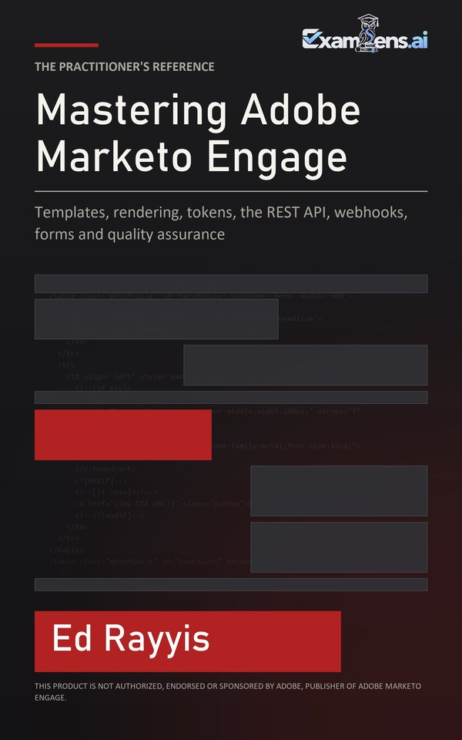 | Mastering Adobe Marketo Engage  Templates, rendering, tokens, the REST API, webhooks, forms and quality assurance  A practitioner's reference for teams building on Adobe Marketo Engage. First edition, 2026.  Kindle and paperback on Amazon: amazon.com/dp/B0HLZ9HV1W

